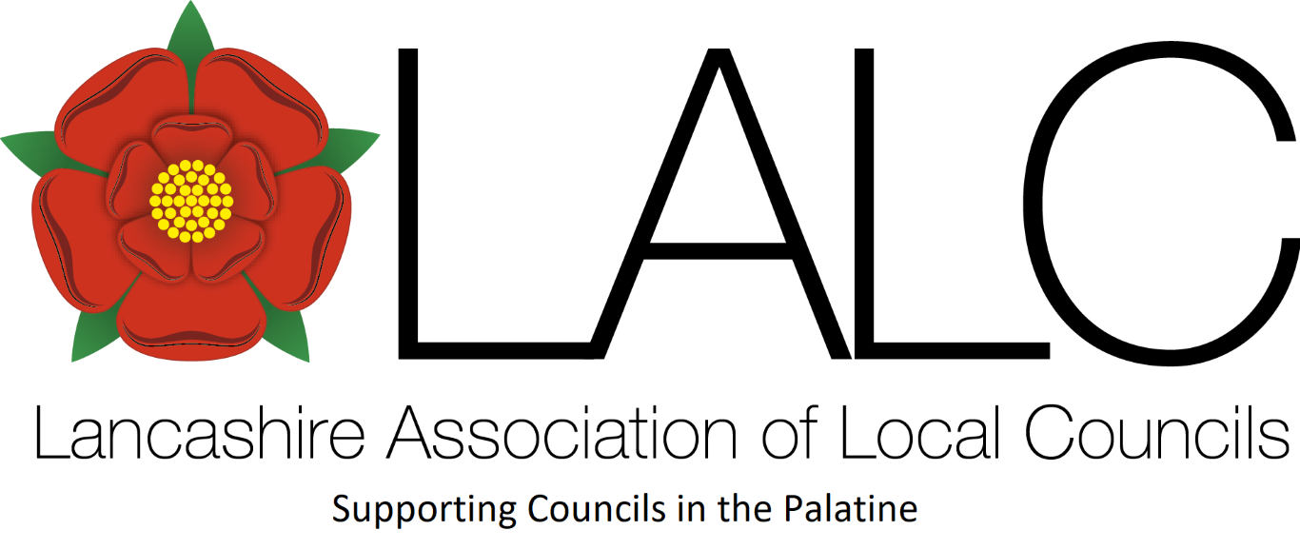
To: Member Parish & Town Councils
& LALC Executive Committee

The 81st Annual General Meeting of the Association
will be held on Saturday 1st November 2025 at 2.30 pm
at Lancashire County Council County Hall, Preston

MOTION to 80th Annual General Meeting, Saturday 1st November 2025

From: ………………………………………….. Parish/Town Council

Proposer: Cllr …………………………………….. who is attending

Seconder: Cllr …………………………………….. who is attending

Council would like to propose the following motion(s) for discussion:

Submission deadline – Friday 24th October 2025

Email to office@lalc.org.uk entitled ‘Motion to the 81st Annual General Meeting of the Association’

